**親愛的三年級寶貝們:**

由於疫情嚴峻的關係‚這學期的課程要繼續在網課中渡過及結束。

也希望你們在家中持續防疫‚照顧好自己的身體和認真課業‚與家人間

互相幫忙‚適時分擔勞務‚期待我們來日再相見。

**郁芬老師**

**06/14~06/18 課程計畫- - - - - - - - - - - - - - - - - - - - - - -**

課本P.98~100

<https://webetextbook.knsh.com.tw/Ebookviewer2/Ebook.html?id=2101072232336>

習作P.42~43

<https://webetextbook.knsh.com.tw/Ebookviewer2/Ebook.html?id=2101072232336>

複習課本 P.52~73

<https://webetextbook.knsh.com.tw/Ebookviewer2/Ebook.html?id=2101072232004>

複習習作P.22~31

<https://webetextbook.knsh.com.tw/Ebookviewer2/Ebook.html?id=2101072232336>

**補充資料**

公視《台灣特有種》微視界HD版第二季 1~3集

1東方草鴞 <https://www.youtube.com/watch?v=nmxkx1q0CMs>

2台灣長鬃山羊 [https://www.youtube.com/watch?v=4y4IpT-O23o](https://l.facebook.com/l.php?u=https://www.youtube.com/watch?v=4y4IpT-O23o&h=AT22BJtiOeXmGpYgT1BwQ3n859jASW7aX4KwEeD6JLeTrv_NFsJrDL-q_q16LZ23hS761C3xqRdtGf_PpAT-op8s-GFTJ0LszCEoBlTaigt2_g16Iswcir40UIbKS_zhVEAMLyy-J315T50zHkqOABH__LKLKLZGS1Or0BYMuhVTjrRmn22e6E-1QaWaL-I20KwhnBtVl-ow7Kwjezx_qPDgoYeAgWw5kyuk4xRyd-Kd25BQcF6IqoYmNFevwKl5o2j32jKNtIfQLOP__56DDJWY6z9kGSnFiM6DQ8uA0NL8Zy2OZG1LAMc7umUzhfdEMRMAVNgn0Cx1-FbIIfFt0riOYS2e3-ttArCcHZ3uhVGmuOODlJWx8vvsTfDzuL_Ch3PIxEpZmsP5V6BQIP9JUPe8cTvmAT3-TsRxES9JB_2e07yMHK3PDfLBxnZZ3Imak1AzMXqHInkuXgbTZUw0j11xBei9X2Ch0vaDn0R3oYTM5zWzxEMLhknW45zTkVekfVenUREWochjOoqU6ipKXoRjE5_n9h90KfJeSnjhWpGssXnEgkD2afljtLsRnJ4kG_thGpC5L7yNrnTaTkHgSulDEhcOsafExA1iUUw)

3台灣寬尾鳳蝶 [https://www.youtube.com/watch?v=hWbTHHGy_Bk](https://l.facebook.com/l.php?u=https://www.youtube.com/watch?v=hWbTHHGy_Bk&h=AT2p3chI4duIJCGmqbqXdXjl1KsO_y8EelI64R7FK7YdzKDliAqf4r6dLHE6kysTlLwJydKIruoNyW0XLcA7Qt0_mfAbQ8RW2T7P1jYkNTd6KLeZ_pkRtyAUk7hOvOK4mOFvMWURDo65WoyvmXgIX4y1VryjRwEc1mvOXn9C6Ed-nZjlCACqA0xe4MYD-dOgfOAEyQSHmPxreazNnfw3CqOXIK9h3e343dPIFgWJFzeAzknNvUA2_gOPpVjSWZSox1Hudaf8NtewqM4cNXgVvQzcq-XlOYoEBB1b9Ln5V_Zq-PGs7QnSoxOALysSHWqiiHN451HNi9y-zDZ-Vtzbk_O4Xo7d8EsD7fRwsmN6QubcidxFFBL8PjoiRxXDAsUj1xd8RjzCs4zPVuN8Ll6NtEmd0ZGk0ffOP0aCpK5Vid_le5WSYsnR4tT5KZql-C21_hOtNYv3a_MrruNacdwdxCwDPmPcSz2izszgmybUmgHliZrmdH2MtCe7MeLZMeN6caPv7H7Rc4WeHDmN_qPvMYGwCzQinMgtpNaoZ0QHsQdN2iSbTjqWD1Ep29kbFqPy4y_qFRWHDVgHyL16OxHPodTcRRL6DF2pS0pRpvw)

**作業複習**

**第三單元 認識天氣 填填看**

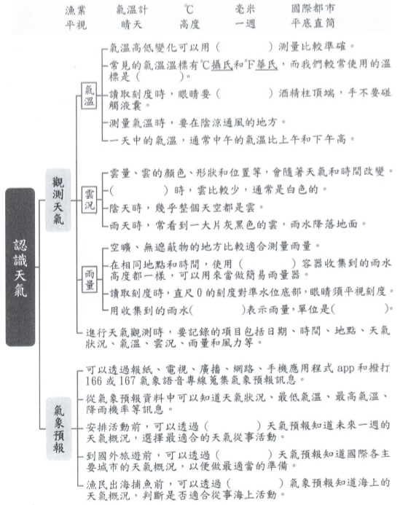

**06/21~06/25 課程計畫- - - - - - - - - - - - - - - - - - - - - - -**

複習課本 P.74~97

<https://webetextbook.knsh.com.tw/Ebookviewer2/Ebook.html?id=2101072232004>

複習習作P.32~41

<https://webetextbook.knsh.com.tw/Ebookviewer2/Ebook.html?id=2101072232336>

**補充資料**

公視《台灣特有種》微視界HD版第二季4~5集

4觀霧山椒魚 [https://www.youtube.com/watch?v=lllNjw4ihxU](https://l.facebook.com/l.php?u=https://www.youtube.com/watch?v=lllNjw4ihxU&h=AT1_1Lz_p_4ZaA7l4HSfV4mHyuQKWi0Uzq-juofPILoKCuhN_Cu2Jt6SP0I-qpZTORN_FblEoyiIEkTa9o0UJxDSkVSIPir1hw1mdX5c7vuSLcn8XuswU9TUXF4Y3qTYACDc18qsnINrw1FzSCk5MtzciJV-1nXn7qOLSqDvJV8rOlpGHLSNKiOP2HBcxvEKX12acQLvT9WsMS9e6qF8wnPfTMrTvujNIPqpv_uxnCDeBkUjaDKSKMf3_BW9z7KxqBASMJhl1EVQrxsSXmpxuZ2IX-Mz7R-5gcFFRoRA8qMNbZxu54oy6GjKaV70Hd457c0W0Q9svk196gzq1tJ5aBmvGqFlnvRV7kIt2fmqS9WB4DHN5eFPdvRYE3N5Nw_UtRViKr_ylb-tVC2c8jT0V--iTsbse43xOJ4H2nFJd7IdpKjnjnoeCI6brsB-i1cQoQ3xZ3N9044D2i61i7-PQtM7iR2wo5zfWsfaLQwEy-t8Umse2oxWNGpOZX2necW6CreDUOL2uFAuxudfxiXNTVljvJWwFrmaQEuCRyANbE3TB1GA7VYHqTE0bKtwWNI4YmV5L3E64GFf7BKhKmAYkqFmfmw36ltuhIjBr3s)

5中華穿山甲 [https://www.youtube.com/watch?v=fSmRHIRlvU8](https://l.facebook.com/l.php?u=https://www.youtube.com/watch?v=fSmRHIRlvU8&h=AT33HZORUozVBsrG1COCRJURvNDI0G9WBXubb5a9DtUJdqQy00TSYJi220j6Kb3-GJq6foepGFF2UcVs_x_P8XOg-PVkolSds2xJFKiX9hdH1JIPnOTORbH3NIogQyCdrpn1miOUz9OeXZhZnOJVBWxZylKsUzVNjLELpQcui0OEGmJ8EpDOc8F69c9JapaTMmpffbS4NCb3M-r4wMDXnLnBwA84DpwgBwLPFmCDOAWY40u3lxnb7P-9jP7tgQPkGeD46FGtF9lZXzSXsPwuPDfGQRnpna_1y0VcInfeOS8RTj5cmFoFpy4HokfeJQEHkcGLgA7fKOsmOh4U2ObCGNisY3IzhRol_ARYuGetnFu-HmmyhxE8ej-xbG1Fj8BXuSZsjozF0JYOIOnDs4l8Voj1KpD6pJFxIMiwnMY3a_QlAjvoK7XrFndfy02Y6VLrG_81socHJp0Zji8ehf7bGADgGn2WbWtxiQA5DZ0nVkVf4QWReC1yfn9ZADtBglbUSFlmy3x6rxDn2ZgZdpGyyUodN1Qthnf5LkGXqO97bvqBAvCrqx4VmlAzGRaFbJiyu3c-IHX8K_AZ5yN6WnLdubE98-Ax3xZLL6p-JWI)

**作業複習**

**第四單元 動物大會師 填填看**

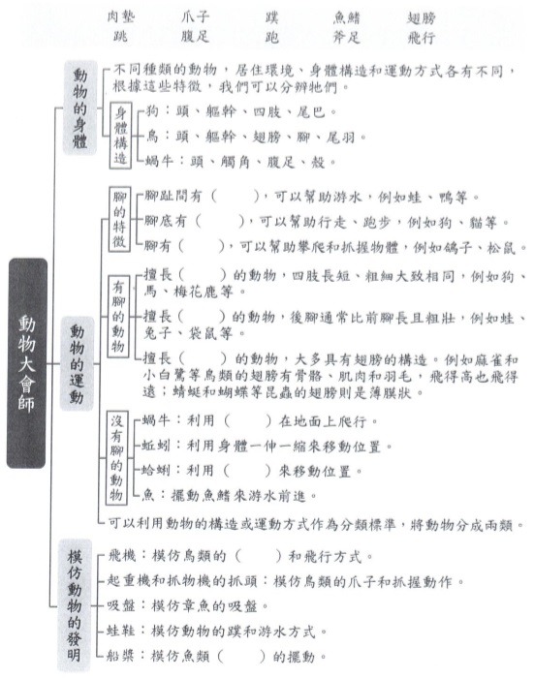

**06/28~07/02 課程計畫- - - - - - - - - - - - - - - - - - - - - - -**

複習課本P.98~100

<https://webetextbook.knsh.com.tw/Ebookviewer2/Ebook.html?id=2101072232336>

複習習作P.42~43

<https://webetextbook.knsh.com.tw/Ebookviewer2/Ebook.html?id=2101072232336>

昆蟲擾西

<https://www.youtube.com/watch?v=C7jrkSN8KY8>

探索獨角仙寶寶

<https://www.youtube.com/watch?v=EjZV4Mmr5YU>

**補充資料**

公視《台灣特有種》微視界HD版第二季6~8集

6中華白海豚 [https://www.youtube.com/watch?v=H8SdB5Sk204](https://l.facebook.com/l.php?u=https://www.youtube.com/watch?v=H8SdB5Sk204&h=AT15bZLn8AZDVUqgJOK91irDXo6u3duelqOBkLChip4e5aFogSyfkABoGYd8uCTP3582PjCaf0R9euctpstJowHrGQq-7qahDzof1I1p68pyrMvlLrRHRAqPm9S5HL5fUyiZp-3DUZ99PegDU9bClSsDhaB_NIGDqeV8-8AWvl3SvMNVqVHRdsOWoTCaasft2FQf-F3Z1XPW6mh44mn-ens-caKz84fHczajQreUt5Y59lv4eUg_5DtyoYrnmBP9moNy40PF4m1eO8CK1T7YOTcDTXTWn0vbXKbTRTltDPmI49fgxxMMki-Qq300guwmyjHqNEsxbRZTWJBfMS_qqy5wnkYGr2IW6dIdbmwy7ddGsGVjmb_6vxcu_gbM_7TMYPLY4Kby7R6sPOYN45fD8t6fFZmg-6BwoddVlGwc1tdwe8LQLXCSMi6k6ncoLyhW91l0_we8AoT4sBaUxOmVKyttnuPYL7H3rJ3TRzu4yebuqtCR2IyiPI20Mz_9CcoEBSytiQcXn79krGnFdUblFFZ3ophSkgxYVZh7IhdJ8q1eLIGLF42WLQNqP4h4x1Sb9QBtB7G4-N7ozJYLBcgcK4gQCR0jB0cF8KaU0U4)

7臺灣擬食蝸步行蟲 [https://www.youtube.com/watch?v=k1RERfF2Z7s](https://l.facebook.com/l.php?u=https://www.youtube.com/watch?v=k1RERfF2Z7s&h=AT0G_GvEh-IhrBQr_7Jr-F9_PI31_GKIjL9I3RGCpAmP9OypZyrY_InNKlXO_qu5q6Tm75whrN9l6JSw68iEutHQUCgUHwphRRwZ8kCZFhlMAbV6RA2wuMt1IbQCRK-fqODX8-Bsr9HIR7vx4AINTpy4UTB5tziglKvddnnj4p4UtMvDEdSbM5g8M_HWs3pgExLQLegqQrY2n1Ut9_j2iqfswirvHFWSfc0IcEV3qVILhdRkLLJ7LPvK55cUDiB4jSaWUmvATWCPlNeHSVijAU-wkvtEdqryPnQg-dfp_W8heQCdozaCPKCQXgJSyjP3uWLF_6BGLpvMNUZz2Jis3lQWYd-pu1AdOrHuI8agdBT9jPhNyH5Wysj0MVHpKPgtzKeyOaXbZlIwBaM1_hUedhc9JALmwWy-JNJMM5qCAbYeMjPgb2F2e0vzPunLs-pQ2bWqvXVdAAruOusD-HGdht1ZYinei8vcj7l7qGH_upJapSQ-7kshgqV2ROayNV0IPRgcwhm4AXW1mGNThIN8eE4Jrb5S04smjpVpfEwWxY5p8KpclEopBRUHxuwvPqkFzgk466T7nRtD7B1qGck5eDIieHOsn9aEG-iOd7M)

8鮭翠斑草蜥 [https://www.youtube.com/watch?v=PXVMuBXm5bE](https://l.facebook.com/l.php?u=https://www.youtube.com/watch?v=PXVMuBXm5bE&h=AT3v38kVThLS-6ECobClq5_Myi4w0QITvTrtjDr2LfB1Gzl4oFs4bNbQa3lHyHwqyDnK5s3eQmEoB1tIRUgps6pS20yTg6c3IsXc37zHdnArOJnkuI03E3Y-hfjAvtlv1eTrpk8Y7IU15lKhyRWgJV3zxOnJYF_fC_KB50aca-Sj2MPlMsDhbV-f8W6ECaVuxG6WJaD2wxazx4i_MByxdWqpecSxjCmy9hIfVgOUx7btiXNeQyUlQ2QusGBobcDStn-6CW2IrB45nNCWIPCMZAudwT9sIwGPMbn_DCv4OoVqIHCq9_X1lWNxM72HVpvGh2ptqb1tYnPygKGXl3n4rNArKikiYnmhZT4NE7QV91kifA6J90kl_ptEwMTwZZqooxgYV4yUrpbqTgiTOy73tooa3_cRz_nyeaGejB1Qhclebxh2k42sCqtSGjmBIh8V_gqM_jyn2DoPhSEiJCAog7EPlhK5dtUKbHskpsEsDfxxHbw-h7BX4Q9gHXLuOAN2-92VdGIHc9MEG1UF2g9gS1OjQ9agqiei9EBHrEuNCwqgG8fl3Rrr4K6WCtHDYw6XYjPgPFY1uujJkvytdfKccn1P50hy_mBqWKJsd3g)